Tuesday, May 6, 2008
7:00 p.m.
25 York Court #3

Meeting Minutes
(PLEASE READ ALL INFORMATION BELOW)

Attendees: Court #1: Sharon Halm (7)
Court #2: Laura Amos (16), Pat Russell (21), Mary Morrant (22), Egbert Bunbury and Denise Lucas (23)
Court #3: Donna Morgan (33), Phil Reely and Michael Bracey (25), Sherry Berlow (29), Jeffery Wasserman (27)

All Residents – please forward your email address to philreely@aol.com to allow for electronic deliver of informative communications related to the courts.

Meeting Minutes can be found at: http://www.pc123smt.com/the_york_courts_of_guilford (underscores between the words ‘the_york_courts_of_guilford’)

7:00 Open Meeting and Welcome Guests

7:02 Old Business
- Financial Report – Phil Reely

DATE | IN | OUT | BALANCE | DETAIL
8/1/2006 | $159.25 |  | $159.25 | Balance forward
8/1/2006 | $205.00 |  | $364.25 | Yard Sale proceeds
9/19/2006 |  | -$20.00 | $344.25 | Welcome basket for #3
9/19/2006 | $50.00 |  | $394.25 | tree donations at picnic
10/1/2006 | $50.00 |  | $444.25 | donation for tree from #7
10/1/2006 | $30.00 |  | $474.25 | donation for tree from #25
10/5/2006 |  | -$146.96 | $327.29 | tree purchase for court #1
7/10/2007 | $88.00 |  | $415.29 | Yard Sale proceeds
12/12/2007 |  | -$15.35 | $399.94 | Holiday Tree lights
2/15/2008 |  | -$40.00 | $359.94 | Welcome basket for #14 and #32

7:05 Open Agenda topics
- Annual Flea Market and Crafts Fair
  - Approved for Saturday, July 12th from 10 am – 3 pm (rain date – Sunday, July 13th – same times
  - Committee meeting notice will be distributed to solicit volunteers and plan for the event.
- Plumbing repairs in court #3
  - Underground plumbing issue was found and resolved by AJ Michaels in front of #21
  - Safford was originally called but there were service quality issues found with this contractor
- Spring cleanup
  - Group effort did not occur due to limited participation interest
  - Proposal to initiate a FRONT YARD FIX UP day for all to consider sprucing up or improving their front yards at the courts on Saturday, May 17th
  - A few homes could use some maintenance to their front yards and maintenance is needed to beds in court #2
  - Laura Amos will write and publish announcement for this event
  - Please join neighbors and help improve the front yard and court appearances
- Automobile vandalism
  - A group of individuals were witnessed on Saturday, May 3rd around 9:30 pm, going through the alley and tossing trash cans –witnessing residents took no action to call GSP or Police as reported later the next day
  - The following morning there was windshield damage discovered to one of our residents’ cars
  - Others have experience similar vandalism to the cars over the past couple months
  - It’s essential that each of us take the appropriate action when witnessing vandals, thieves or any other questionable individuals in or around the courts which includes calling GSP and 311 OR 911 for emergencies
  - All residents are covered by GSP regardless of having paid those fees. Those who have not paid the fees are not permitted to enjoy the extra benefits but ALL have access to the security car for security issues
  - Not taking action allows these individuals to be inclined to return – please make the call and have these people caught at the time you see them
  - Residents call GSP and police on Sunday but at that time it was too late to catch the vandals
- GSP response to Courts from Alley
  - Security patrol has difficulty finding specific addresses when approaching from the alley
  - Please provide signage to the back of your home that indicates the house number
  - Sharon Halm will create a courts diagram that identifies each home and its address for provision to the GSP to also assist them
- Alley and pass-through walkways – trash
  - Debris has been bagged and left in the alley at the pass-through between courts 1 and 2 and must be removed
  - 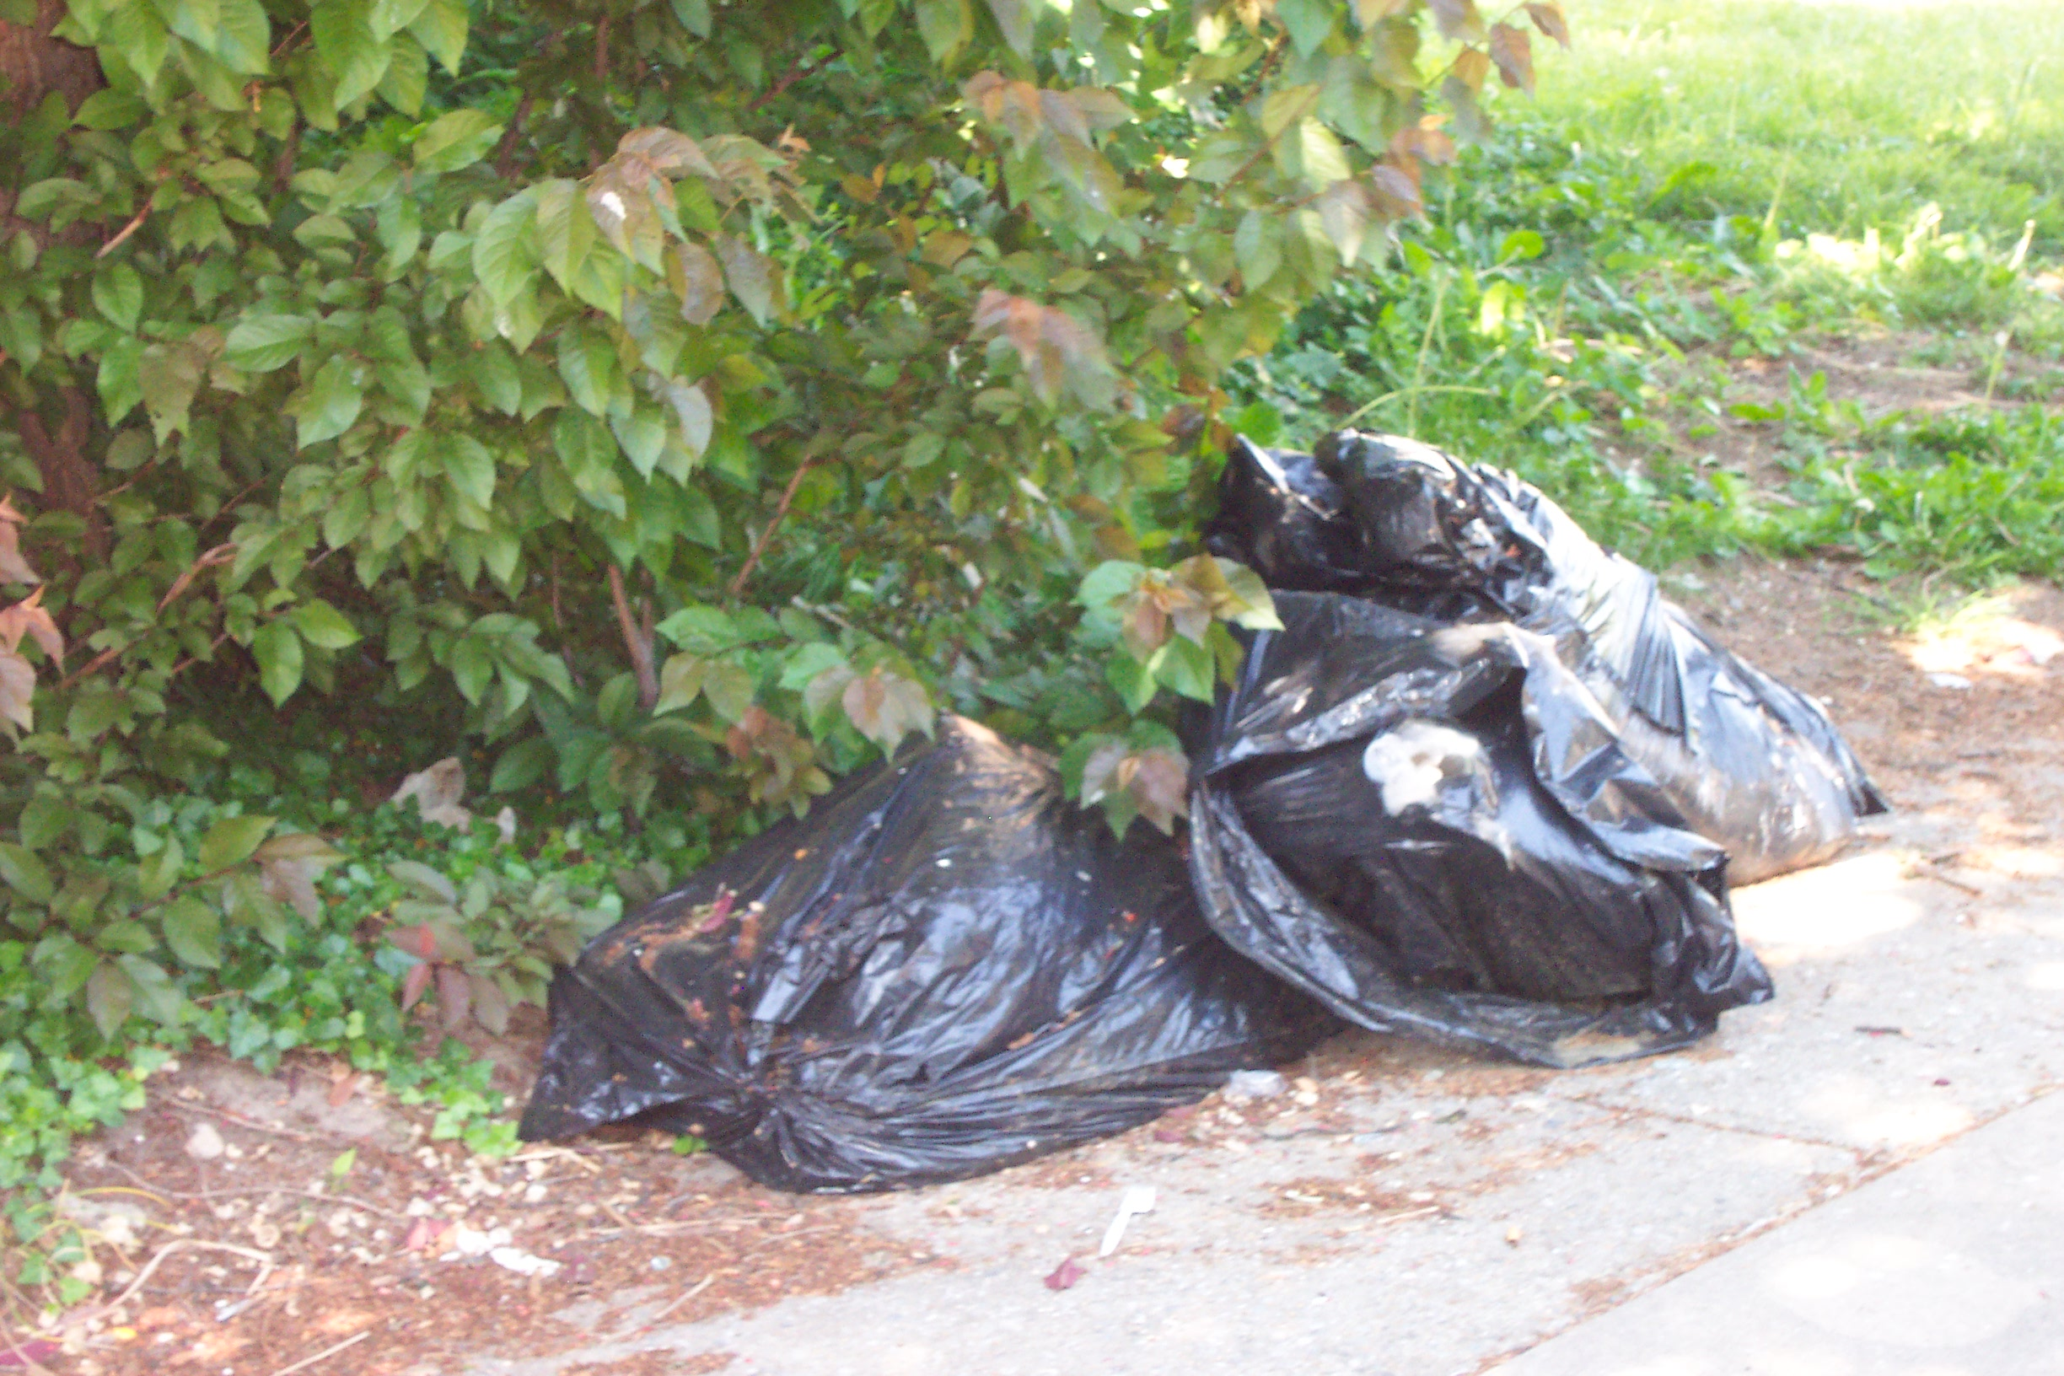
  - If this is from your home, please take the appropriate action to remove the debris and/or coordinate it’s removal via 311 (phone or internet)
  - Trash cans continue to be left in the alley and create alley passage issues when strewn about – please make effort to return your cans to your yard
  - Trash bags are NOT to be left in the alley but must be contained in trash cans with lids. This is a city law and ordinance. Failure to place trash is cans can results in fines to the home owner
- Alley and pass-through walkways – maintenance
  - Overgrowth continues to be a hindrance to some residents when attempting to use the pass-through between courts 2 and 3 (placing trash out, etc.)
  - All residents bordering a pass-through are asked to please maintain the hedges and overgrowth for easy passage by your neighbors and to improve safety and security
- Alley and pass-through walkways – lighting
  - Lighting the darker areas of the courts can improve safety and security for our residents and help to deter vandals and other criminal minded individuals
  - Please consider helping to ensure safety to all by:
    - Installing motion sensor lighting at the back of your home
    - For those homes bordering a pass-through in the middle of each court, please consider installing motion sensor lighting – if needed, others are willing to provide financial contributions to this effort
    - Consider motion and/or light sensor porch lights – many areas of the front of our homes are very dark at night; for those that use their front entrance this creates a high risk safety issue – if needed, others are willing to provide financial support for installation of the appropriate lighting solution
    - Please call 410.235.3860 for more information
- 2 York Court #2 - New owner/resident
  - Residents expressed concerns regarding the handling of trash, debris and bulk items that were placed in the walkway and alley
  - The new residents were approached regarding the city ordinances and provided guidance on appropriate disposal of bulk items
  - Subsequent removal of the debris occurred but there are 3 bags of debris that remain in the alley that the residents indicated does not belong to them
  - Phil will attempt to reach the owners to welcome them to the courts and help provide information regarding the courts, trash collection, etc.
  - A letter was written and delivered to the residents at 2 York Court by one home owner which implied it represented residents of court 1 and 2 though not all residents were aware of the letter and/or its content; nor were copies provided to all residents and/or approval provided by each to include them – the residents at court 2 replied to the letter but that response was delivered to only of few residents
  - Mary Morrant will work with Denise Lucas to compile a chronology of the events that have occurred and provide copies of both letters
  - If a amiable solution to the issue(s) cannot be resolved by the residents at the courts, the information will be provided to the Guilford Association and a request for their involvement will be provided
- Tree issues
  - Trees that are growing over onto the property of others is causing damage to property, please have your trees pruned and trimmed in consideration of the property belonging to others
  - If your tree growth is enveloping phone or electrical wires, please call Verizon and/or BG&E for scheduling of the tree trimming
- House balustrades
  - Residents expressed interest in revisiting a balustrade restoration project
  - Grants could be acquired to fund this project
  - If you have information for any contractors that are familiar with balustrade design and restoration, please pass the information on to philreely@aol.com or call 410.235.3860
- Grounds maintenance – Court #3
  - In the fall, Beechfield removed 2-3 shrubs at the southeast side of the court parallel to Greenmount Ave with the explanation that they needed to do so to gain entrance for their equipment
  - This was reported to GA in the fall but no action followed
  - The issue was reported again in the spring when Beechfield regained entrance to court 3 via this opening and cut other planting growth at that location
  - Though its not clear why the existing entrance along the south of the court wasn’t used and/or why they decided to remove shrubs, they’ve concluded that all future entry will be made via the south side of the court
  - GA response to our request to have Beechfield replace the growing shrubs they removed is they will not be replaced
  - We’re very disappointed that GA is unwilling to negotiate and/or require Beechfield to restore the shrubs they unilaterally decided to removed
  - Unless an alternate solution is presented by GA, we will pursue other alternatives to having these shrubs restored.
8:10 Upcoming Events
- YCoG – Front Yard Fix Up – 5/17/08 10 a.m.
- York Road Partnership – 6/4/08 7:15 p.m. – St. Mary’s Church
- York Courts Annual Flea Market and Crafts Fair – Saturday, July 17th 2008
- YCoG Quarterly Meeting – August 5, 2008 7 p.m. – location TBD
8:25 Announcements
- Jessica Quijano and Jeffery Wasserman of 27 York Court #3 were wed on May 30th
- Two long term feline residents of York Courts recently passed away including that of The Smiths at 26 York Court #3 and Phil Reely and Michael Bracey at 25 York Court #3 – they will both be terribly missed.
- Welcome our newest resident Jeff to 16 York Court #2
8:15 Adjourn

